LAB EXPERIMENTS 1 – 6

Name : Ragavarthini M
Reg No : 192311015
Course Code : CSA4301
Course Name : Internet Programming

Experiment-01
A local library needs a website to streamline operations and enhance user experience. The site will include a catalo for searching and viewing books, user accounts for borrowing and managing books, and an admin dashboard for managing inventory and user data. Essential features include a search function, book details page, user login system, and contact form, The system helps both students and library managers to keep constant track of all the books available in the library. It allows both the admin and the student to search for the desired book. It becomes necessary for colleges to keep a continuous check on the books issued and returned and even calculate fines.
Librarian Admin:
- Login
- Add Book
- Update/Delete Book
- Issue Book for student
- Return Book Status
- Make Fine
- Update material (year, semester wis)
- View material
User:
- Login
- Register
- Search Book
- My Borrow History Book (Issue Date, Exp Date)
- Check Fine
- Search material (year, semester wise)
- Download material
- My profile
Aim:
To develop a Library Management System to manage books, student accounts, book issues, returns, fines, and study materials.
Code:
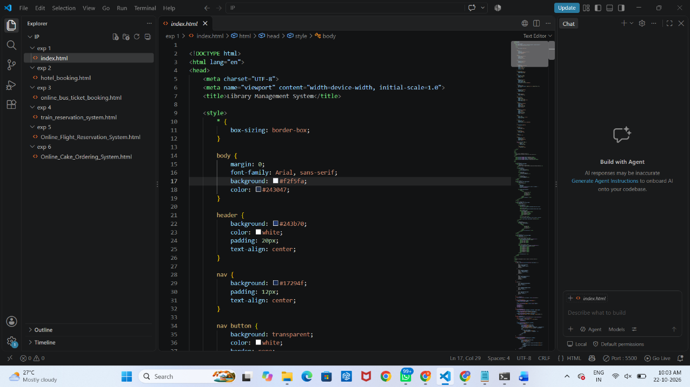

Output :
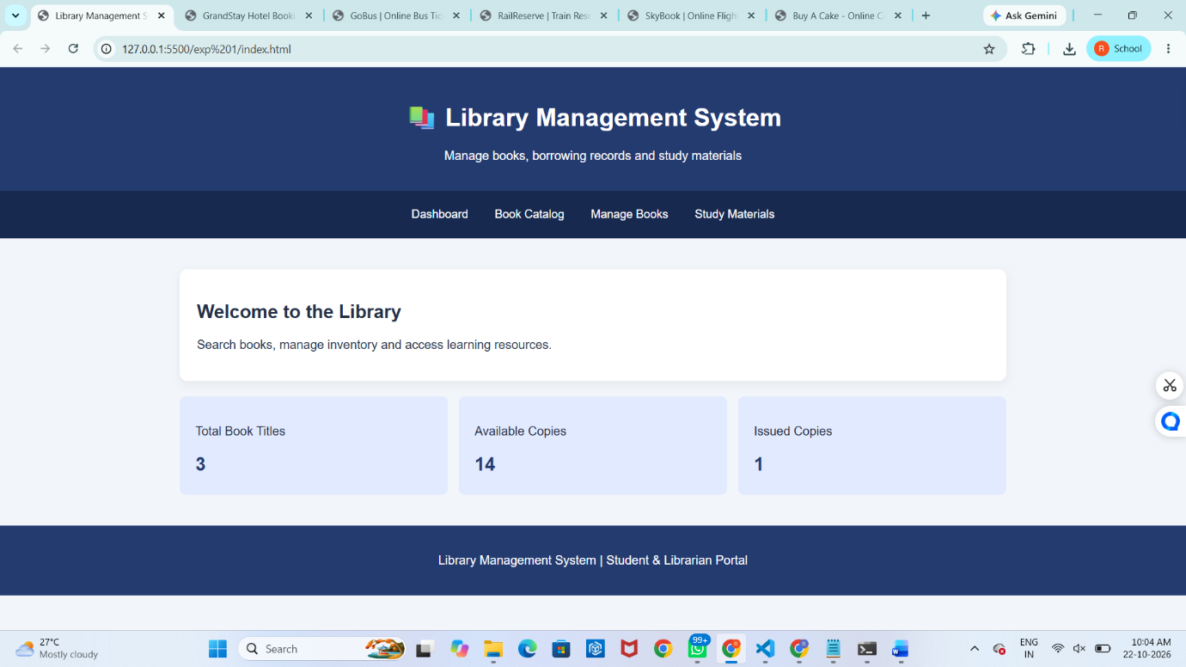

Result : The system simplifies library operations, reduces manual work, and helps students and librarians manage books efficiently.

Experiment – 02
The online hotel room booking website allows users to search for hotels based on destination,dates, and number of guests, offering detailed listings with room options, prices, amenities,and reviews. Users can create accounts, log in, and manage their bookings through a user-friendly dashboard. The booking process includes checking room availability, filling out abooking form, and completing secure payments via an integrated payment gateway. Post-booking, users receive confirmation emails and can leave reviews and ratings. Admins manage hotel listings, room availability, and user accounts through a dedicated admin panel.
The website is fully responsive, ensuring seamless access on all devices.
Functionalities:
Users.
1. Users can register at the hotel and then they can view or modify their profile.
2. Users can book a room on any specific date.
3. Users can view all their booking history at the hotel.
4. Users can change the booking at any time 3 days before the arrival date.
5. Users can cancel the booking at any time 3 days before the arrival date.
6. Users can check the room availability at the hotel before they book a room.
Administrator
7. Administrators can change the quantity and price of all four types of rooms.
8. Administrators can change any specific booking details.
9. Administrators can cancel any specific booking.
10. Administrators can modify the details of static pages including room information, about us
information, contact us information, customer service Q&A details, local travel and shipping
guide, and privacy policy after login.
11. It should also contain a basic room type introduction, contact information, customer service
Q&A, local travel and shipping guide, and a privacy policy
Aim : To develop a hotel booking website for room reservations, availability checking, and booking management.
Code :
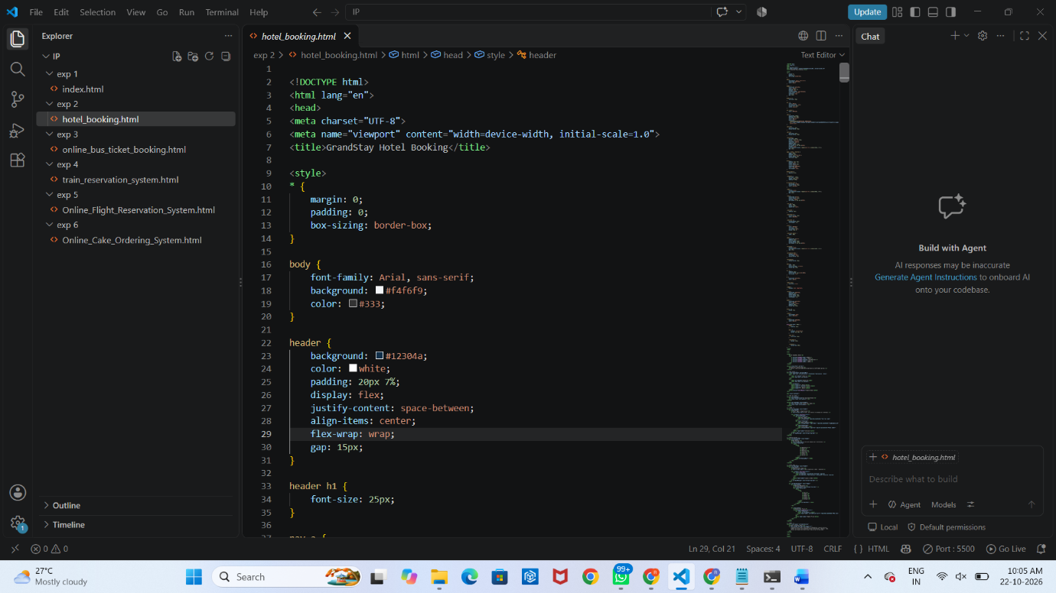

Output :
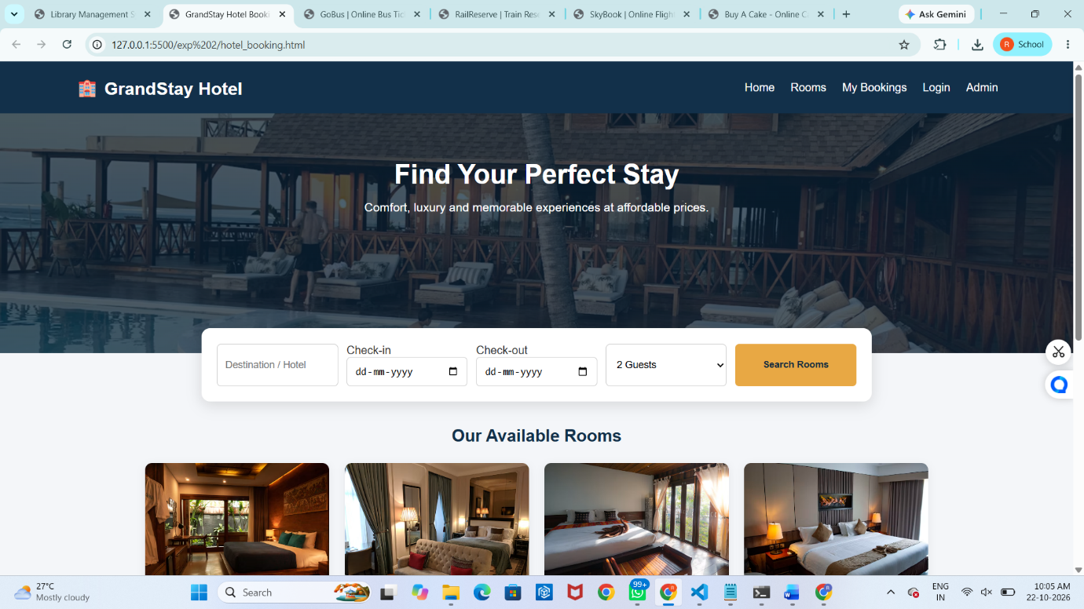
Result : The website simplifies room booking for users and helps administrators manage rooms, prices, and reservations efficiently.

Experiment – 03
The online bus ticket booking system enables users to search for buses by route, date, and time, and view available seats. Users can create an account, log in, and manage their bookings through a personal dashboard. The booking process includes selecting seats, filling out passenger details, and making secure payments via an integrated payment gateway. Admins can manage bus schedules, seat availability, and user accounts through an admin panel. Users receive booking confirmation emails and can view their booking history. The website is mobile-responsive, ensuring easy access on all devices.
Admin
In this system, the admin can maintain all the Bus information and maintain Bus category, comments etc.
In this system, the admin can maintain the registered users, manage news, and the admin can generate reports and manage the whole system.
Login:
Login Module includes various utilities like User Authentication, Change Password and Forgot Password.
Registration:
This website provides some facilities users can be Registered in this website. user can use this
facility so user can make a registration
Book the Ticket:
In this module, the admin can add a new bus category using this module. Bus Category contains
like Volvo, Slipper coach, coach etc.
Update Bus Information:
In this module, the admin can add or Update Bus using this module. It contains information
about the Bus type, photo, description, Location of the tour, Available Seats in Bus etc.
Cancel the Booking Ticket:
In this Module, the User can cancel the booking Ticket.
Comments:
In this Module, Users can Post Comments on a particular Bus.
Report Generation:
This module is used to generate a report.
Aim : To develop an online bus ticket booking system for searching buses, selecting seats, booking tickets, and managing user accounts.
Code :
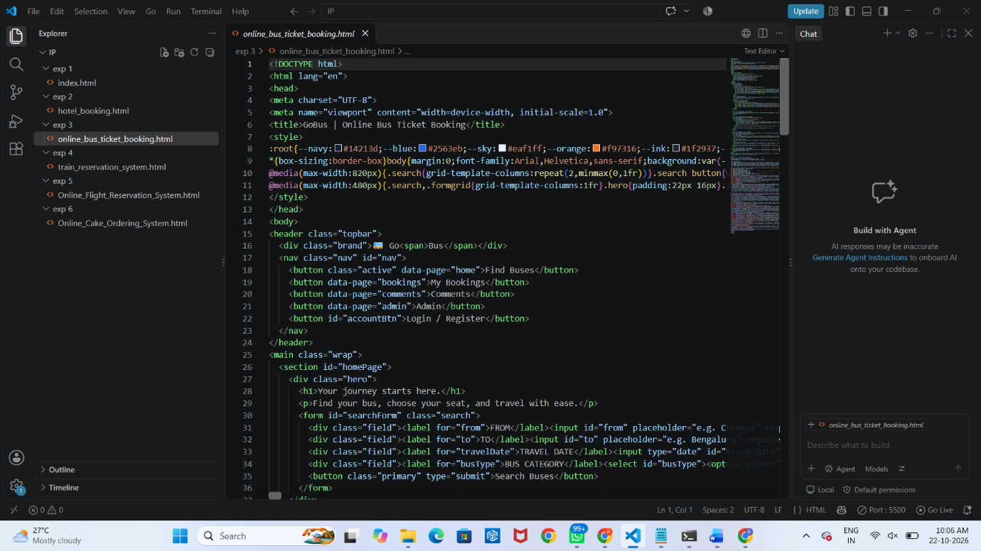
Output :
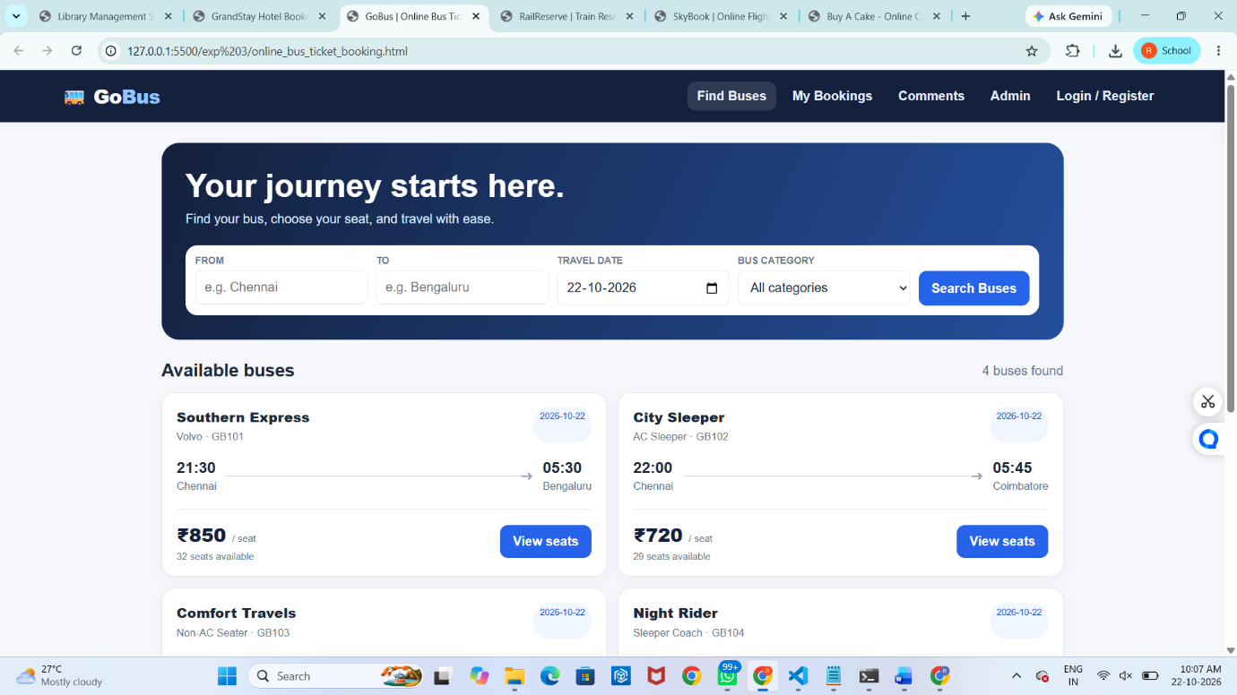
Result : The system simplifies bus ticket booking and enables the admin to manage buses, users, comments, and reports efficiently.

Experiment – 04
The online train reservation system allows users to search for trains by route, date, and time,and view available seats and classes. Users can register, log in, and manage their reservations through a personal dashboard. The booking process involves selecting seats, entering passenger details, and making secure payments via an integrated payment gateway. Admins can manage train schedules, seat availability, and user accounts through a comprehensive admin panel. Users receive booking confirmation emails and can view their booking history and print tickets from their dashboard. The website features real-time seat availability updates and is fully responsive for seamless use on all devices.
The Reservation system should contain the following features:
1. If a passenger wants to reserve ticket(s), firstly, he/she has to log in to the Railway system with valid credentials. Then, the passenger has to provide his/her details with the date of the journey, names of the passengers and their details, origin station details, destination station details, and the class type of the required ticket(s).
2. The Railway Reservation System will provide the available Train-list, and Seat-availability, via-details.
3. To book a ticket passengers can pay through online/offline mode. After successful payment of the ticket fare the System will generate the ticket and PNR no. will be given to the passenger. The System also keeps the payment details and sends them to the system Admin.
4. The Passenger can check PNR status (confirmed, RAC, waiting list) by entering the PNR no. into the Reservation system.
5. The Reservation system should store all train details, fare details (by zone, class,and date wise), PNR no, date of trains, etc. This maintenance should be controlled by the Admin.
6. The System also has refund rules which have a date of reservation, ticket fare, and refundable percentage. The passenger can simply cancel the ticket(s) by entering the PNR no and a cancel ticket request. After cancellation, the admin will pass the refundable amount to the System and the System will give the refundable amount to the passenger.
Aim : To develop an online Train Reservation System for searching trains, checking seat availability, booking tickets, and managing cancellations and refunds.
Code :
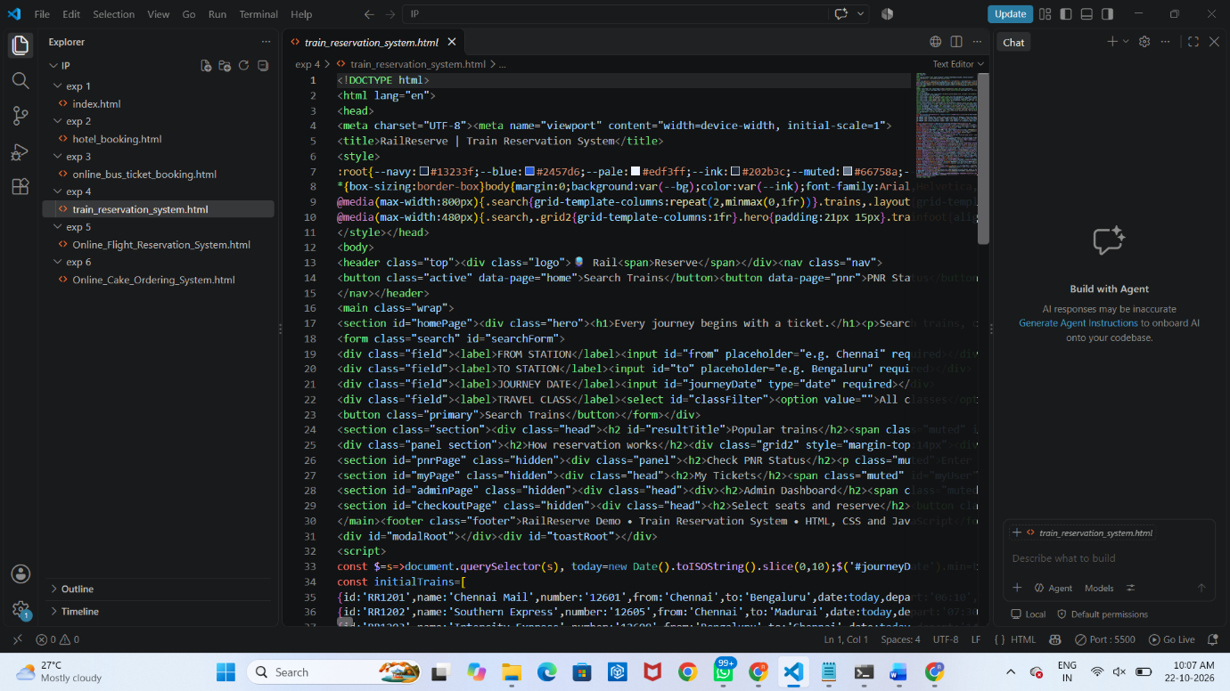
Output :
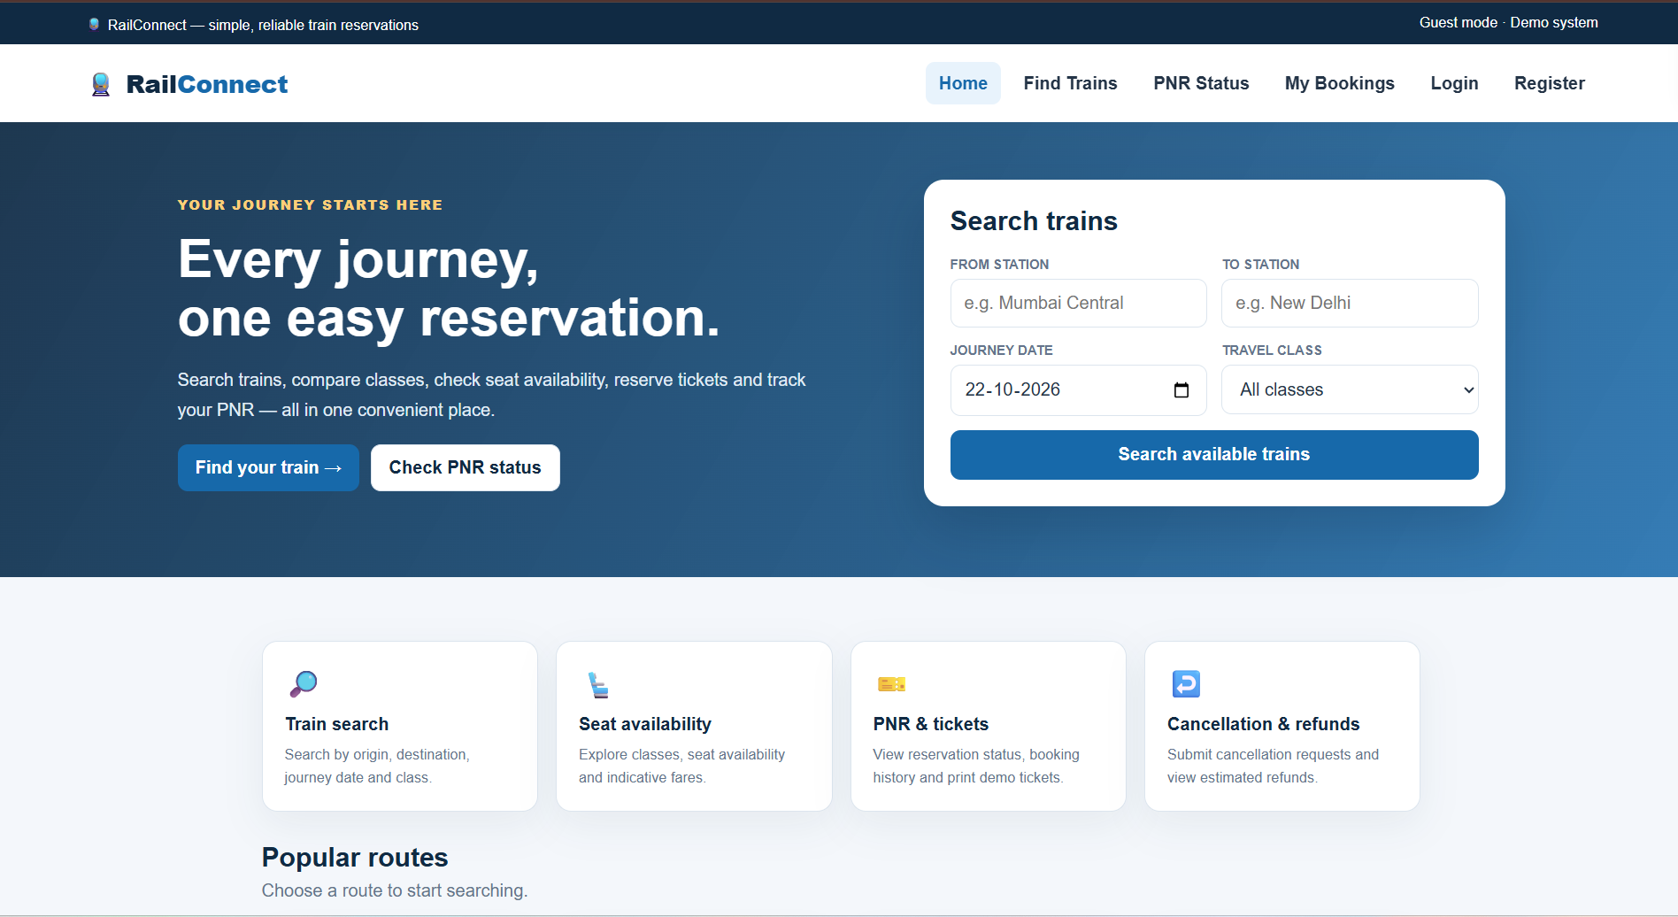
Result : The system simplifies train reservations by generating tickets and PNR numbers and allows users to check PNR status, view booking history, and cancel tickets efficiently.

Experiment – 05
The online flight reservation system enables users to search for flights by destination, date, and class, displaying available options with real-time seat availability.Users can register, log in, and manage their reservations via a personal dashboard. The booking process includes selecting flights, choosing seats, entering passenger details, and making secure payments through an integrated payment gateway. Admins can manage flight schedules, seat inventory, and user accounts using an advanced admin panel.Users receive booking confirmation emails with e-tickets and can view their booking history and travel itineraries. The website is fully responsive, ensuring an optimal experience on all devices.The airline reservation system is a web-based system that helps in consolidating flight data - flight schedules, seat availability, flight fares and reservations from all airlines with the help of global distribution systems and provides real-time inventory and rates for customers and travel agents to book flight tickets online.
- Administrator User Login Page
- Forgot Password Page
- Search Flight Page
- Book Ticket Page
- Ticket Payment Page
- My Ticket Page
- Cancel Ticket Page
- Customer Feedback
- Admin Report
- Search Flight Page
- View Booking Status Page
- Print Ticket Page
Aim: To develop an online Flight Reservation System for searching flights, checking seat availability, booking tickets, making payments, and managing reservations.
Code :
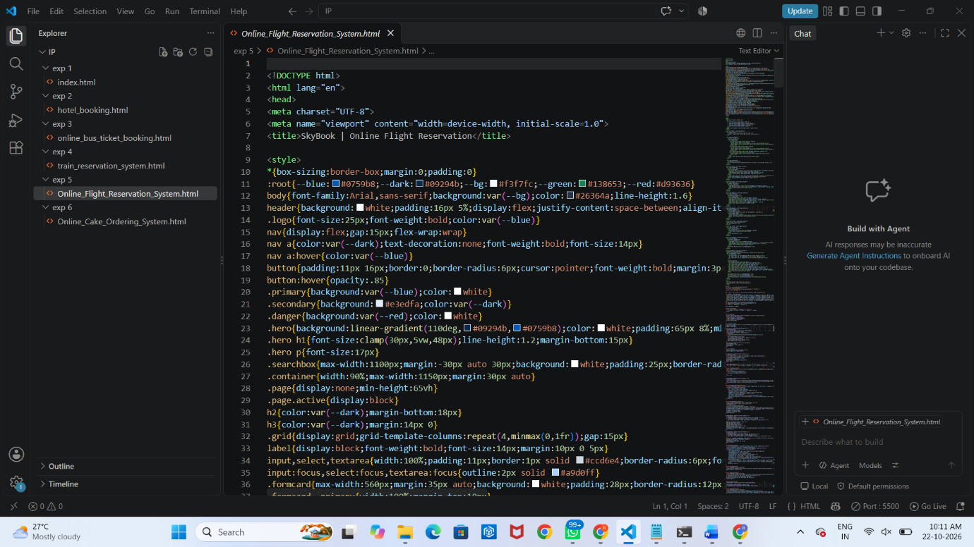
Output :
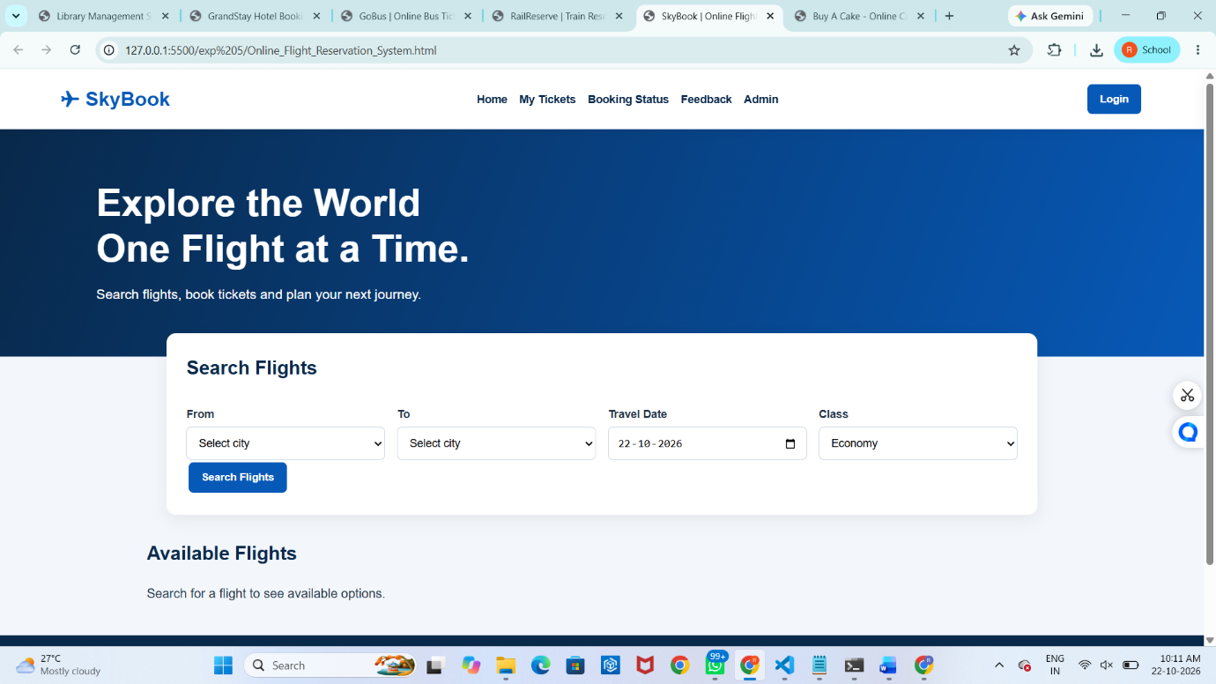
Result : The system simplifies flight booking by providing ticket confirmation, booking status, ticket cancellation, and printing facilities, while enabling administrators to manage flights and generate reports.

Experiment – 06
The online cake ordering system allows users to browse a variety of cakes by category, flavor, and occasion, complete with detailed descriptions and images. Users can register, log in, and manage their orders through a personal dashboard. The ordering process includes selecting a cake, customizing options like size and message, entering delivery details, and making secure payments via an integrated payment gateway. Admins can manage cake inventory, track orders, and handle user accounts through an admin panel. Users receive order confirmation emails and can track delivery status. The website is fully responsive, providing a seamless shopping experience on all devices. Buy a Cake is a portal which allows admin in developing counters to advertise and sell their cake. This would permit rural communities to make their wares available to the rest of the world. The proposed system is to develop the website for cake store. User can buy the nearby cake available in app. An E Com App is a portal which allows admin in developing products to promote and sell their goods. This would permit rural communities to make their wares available to the rest of the world.Admin
- Login
- Manage Products
- Post Cake details
- Upload images
- Product
- Description
- Manage Orders
- Update order Status
- Shipping Location
- Logout
- Student
- Register
- Login
- Search Cake
- Filter
- Category
- Sub category
- Price Range
- View Cake list
- View cake description
- Add to Cart
- Place order
- Add Shipping Address
- Update Shipping Address
- My Order
- View Shipping Status
Aim : To develop an online Cake Ordering System for browsing, searching, customizing, and ordering cakes with delivery details.
Code :
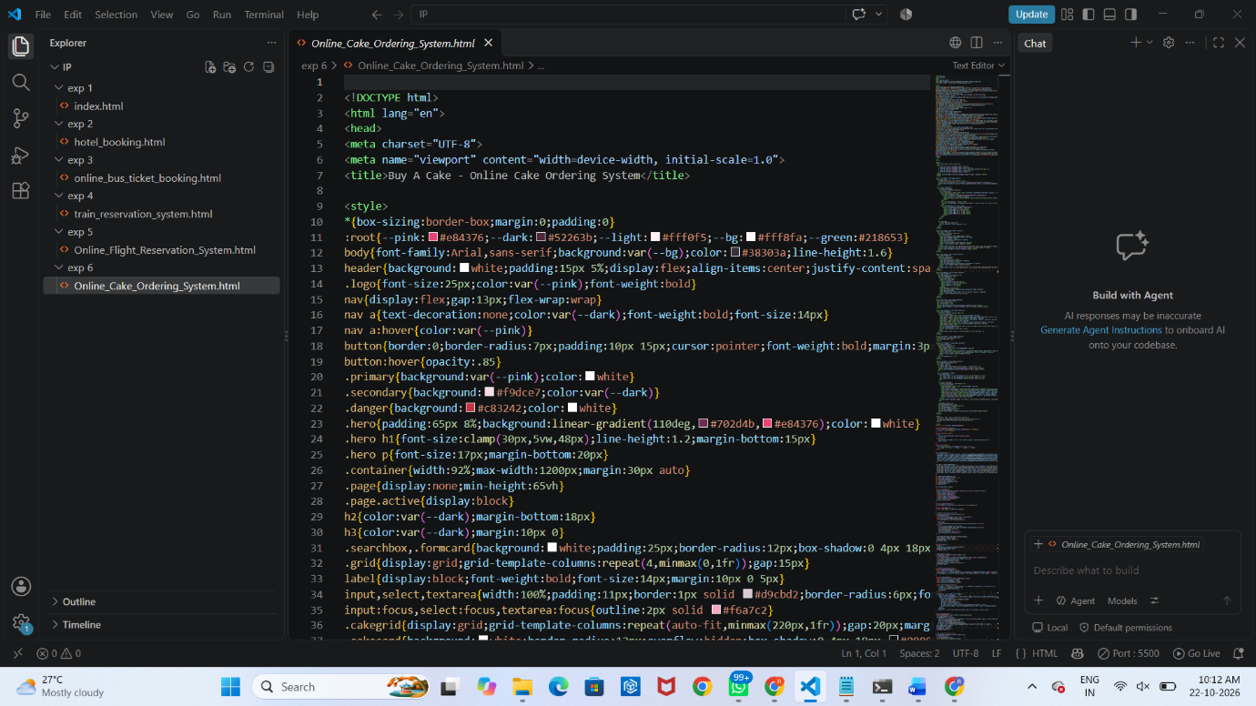
Output :
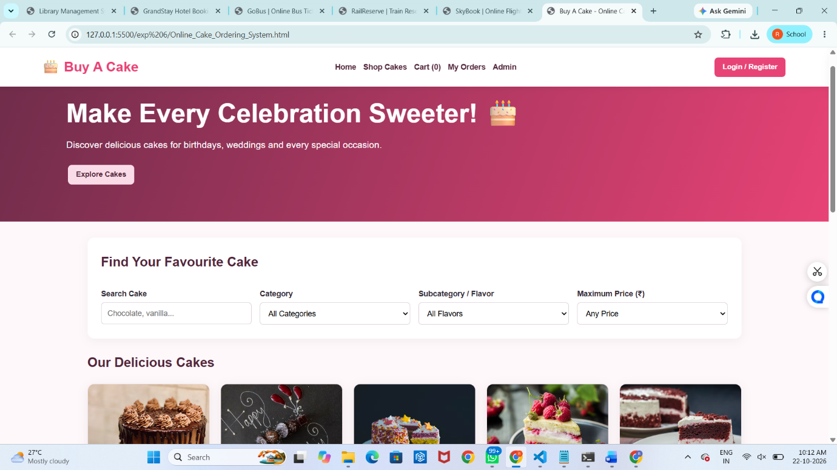
Result : The system enables users to order cakes and track deliveries, while administrators manage cake products, images, orders, and shipping status efficiently.

